A1Wa Histograms with unequal class intervals

When drawing histograms, it is possible that the intervals will not have the same width. In the case where the class widths are unequal, special care needs to be taken in constructing the histogram with unequal class widths, given that each bar (or rectangle) of the histogram is proportional to the frequency. Which of the two histograms for the following distribution is correct (Table 1)?

Class | 0 - 2 | 2 - 4 | 4 - 6 | 6 - 8 | 8 - 12
Frequency | 3 | 3 | 3 | 3 | 3
Table 1

If we plot these values onto graph paper, then Figure 1 would result. Although class (8-12) is twice the width of the other classes, histogram A gives equal weighting to the frequency for all classes.

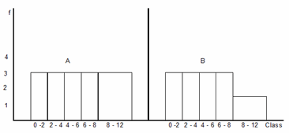
Figure 1

It is therefore incorrect. Keep in mind that area of a rectangle is proportional to frequency and thus

Height = (1)

Histogram B indicates the correct weighting to the class (8-12). Since the class width is twice the width of the other classes, the height of the rectangle is halved. In general, if we choose a standard class width, a class having twice the width will have a height of 1/2 of its frequency; three times the width a height of 1/3 of its frequency and so on.

Example

Construct a histogram for the following distribution of discrete data (Table 2).

Class | 118-121 | 122-128 | 129-138 | 139-148 | 149-158 | 159-178
Frequency | 2 | 6 | 14 | 31 | 63 | 28
Table 2

Taking the class (129-138) as our standard class width (class width = 10) then we can use the following formula to calculate the heights of each individual bar (or rectangle).

h = f (2)

Where CWs = Standard Class Width = 10, CW = Class Width, f = Class Frequency, and h = Class height (height of rectangle). The calculation of the class widths is illustrated in Table 3.

Class | 118-121 | 122-128 | 129-138 | 139-148 | 149-158 | 159-178
Frequency | 2 | 6 | 14 | 31 | 63 | 28
LCB | 117.5 | 121.5 | 128.5 | 138.5 | 148.5 | 158.5
UCB | 121.5 | 128.5 | 138.5 | 148.5 | 158.5 | 178.5
Class width | 4 | 7 | 10 | 10 | 10 | 20
Calculation of Height | (10/4)*2 | (10/7)*6 | (10/10)*14 | (10/10)*31 | (10/10)*63 | (10/20)*28
Height | 5 | 8.6 | 14 | 31 | 63 | 14
Table 3 Calculation process to calculate the class height

Figure 2 illustrates the completed histogram for the Example 1 data set.

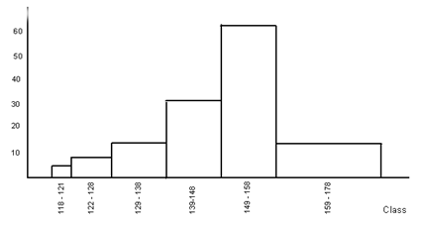
Figure 2

It is important to note that:

(a) Since the height of the rectangle is proportional to class frequency and class width, we can use the term frequency density rather than frequency.
(b) Total area is proportional to total frequency.

Unfortunately, you cannot create a histogram with unequal class widths using Excel but you can create the frequency distribution by inputting the upper and lower class intervals. These are called Bins in Excel.

Check your understanding

X1 Table 4 represents the time taken for each of 470 people to climb the stairs.

Time, t (seconds) | Frequency
40 < t ≤ 60 | 100
60 < t ≤ 70 | 60
70 < t ≤ 80 | 90
80 < t ≤ 85 | 70
85 < t ≤ 90 | 60
90 < t ≤ 120 | 90
Table 4

(a) Construct a histogram using graph paper.
(b) Use this histogram to estimate how many people took between 55 and 65 seconds.

